User Manual 300B SET TT

Overview

The 300B SET TT is a single ended triode tube amplifier. The TT refers to the 300B Triode being driven by a Sovtek 6C45 Triode.
Both, the 300B tube and the 6C45 tube have their own fully independent power supply. AC is rectified via solid state diodes. This makes for a stiffer supply. Bigger capacitors can be employed for smoothing and therefore more energy can be stored and made available when demanded by the music being played.
The 300B cathode is heated via a Rod Coleman DC filament supply. The 6C45 tube also employs DC for the heater supply. The result is a very quiet operation of the amplifier.
The 300B tube is biased via negative bias supply voltage on the grid (Fixed Bias). This can be adjusted via a variable resistor through the rear panel. However, when the amplifier is shipped with the tubes supplied, the bias is set at 70 mA, the point of the lowest Total Harmonic Distortion.
All transformers and chokes are made by Hammond.
Unless specified, interstage coupling capacitors are Solen made in France
The top, bottom and rear plate are mirror finish stainless steel. Only a soft cloth should be used for dusting and cleaning as the delicate surface scratches easily. The wooden enclosure is made from Western Australian hard wood (Jarrah). Four coats of clear polyurethane give it a nice, hard wearing finish.
Before shipping, the Amplifiers are tested for correct voltages and bias settings and they also will have spent an hour or so hooked up to our speakers playing some music. This is to make sure that there are no unexpected problems.

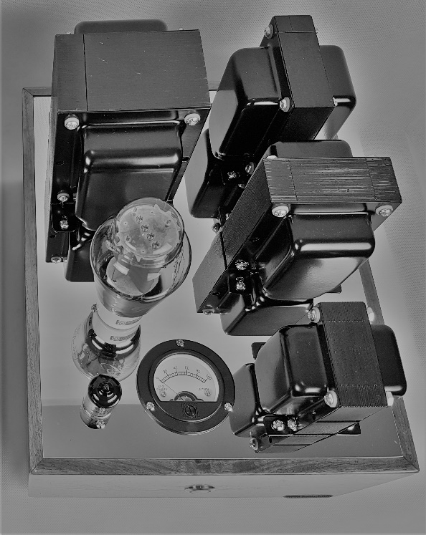
Output Transformer 300B DC supply choke

300B Tube Power Transformer for
300B supply

Power Transformer for
6C45 Tube 6C45 supply

Bias Meter On-Off Button

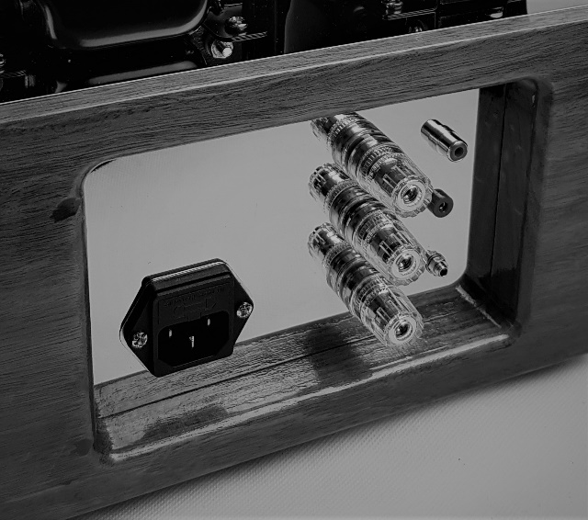
16 Ohm Speaker +
Input
Speaker Negative
Bias Test +
8 Ohm Speaker +
Bias Adjust
240V IEC

Bias adjustment

The bias for the 300B tube is set at 70mA. This will have the anode at around 390V and the dissipation will sit at a comfortable 28 Watt. These settings will equate to low distortion and long tube life.
Lowering the Bias will increase the anode voltage. Some makes of tubes can start to arc at voltages higher than 400V.
Adjusting the bias is usually required when a tube is getting old and electron emission from the cathode is dropping. Changing out tubes will also require the bias to be adjusted.
The bias meter on the top panel is giving a good indication of the bias. For a more precise measurement a multi meter set to Vdc, can be employed. On the rear panel the positive test lead needs to be inserted into the Bias Test +, the negative test lead has to touch one of the bolts holding the transformers on the top panel.
Insert a small flat head screwdriver into the Bias Adjust, slowly turning the screwdriver and gently pushing it in until you feel it engage.
Slowly turn the screwdriver whilst watching the multi meter or the Bias Meter on the top panel. The bias is measured across a 10 Ohm resistor and therefore the multi meter will read 0.700V (I=V/R=0.70V/10 Ohm=70mA). Adjust to the desired level. The bias adjustment should be done when the tube is hot. If a new tube has been fitted, the initial adjustment needs to be done when first turned on and then again after around 30 minutes of running the amplifier.
Bias check and adjustment are done without a signal applied

Operation of Amplifier

Set up and turn on for the first time
Make sure there is enough ventilation the prevent heat build-up around the amplifiers.
Do not turn on the amplifier without the speakers connected!
- Connect speaker to the appropriate speaker terminal (8 Ohm+ =bottom, negative=middle, 16 Ohm+ =top). Using not the correct terminal is not advised. The speaker impedance is reflected back through the output transformer to the tube via a mathematical formula. The operating point of the tube is selected accordingly and an incorrect load will compromise the correct operation of the tube.
- Connect your preamplifier to the RCA terminal on the rear panel (Red=right, White=left)
- Connect the power cable to the amplifier and plug in the wall plug.
- Turn on the preamplifier.
- Turn on the amplifier and ensure that the bias meter reads approximately 70mA after a few seconds.
- Enjoy the music
- Turn off the power amplifiers before turning off the preamplifier.
What not to do
- Never turn the amplifiers off and back on in quick succession. The tubes don’t like it.
- Never turn the amplifiers on without a load connected.
- Keep inquisitive hands away from tubes. They get very hot when in operation and stay hot for a while after turn off.
- Do not set up the amplifier in a cabinet without good ventilation.

Warning!
- If you do not know what you are doing, never open the amplifier to attempt alteration to the circuit or attempting to fix a problem. Lethal voltages can be present even when the amplifier is unplugged.

Specifications

Description: Class A single ended triode amplifier in mono block configuration.
Power output at onset of clipping: 10W per channel
Total Harmonic Distortion at 1khz/1W: 0.20%
Frequency response: 26Hz to 68kHz, -3dB (47Hz to 38kHz, -1dB)
Input impedance: 200K Ohm
Input sensitivity: 2.2Vrms to full output
Output impedance: 8 Ohm and 16 Ohm (see text at top)
Weight: 16 kg each
Height: 270mm
Width: 255mm
Depth: 325mm
Power Consumption: 90W/channel

For any technical problems or general enquiries, please contact us via e-mail.
info@undergroundsoundaudio.com

